EXTRAMURAL ECTOPIC URETER IN A FEMALE GOLDEN RETRIEVER: CASE REPORT

Doralice Araújo Lourenço
Iury de Azevedo Rodrigues da Silva
Elaine Lopes de Carvalho
Rosa Maria Cabral

ABSTRACT

Ectopic ureter is a congenital abnormality in which the terminal segment of one or both ureters is located distal to the vesical trigone of the urinary bladder (UB). They can be classified into extramural ectopic ureters, which completely bypass the UB, or intramural ectopic ureters, which traverse the UB submucosa to open into the urethra or vagina. This study reports the surgical correction of an extramural case in a 4-year-old, spayed female Golden Retriever weighing 35.5 kg, treated at a private veterinary hospital in Belém, Pará, Brazil. The animal was referred to for surgical clinical consultation due to complaints of urinary incontinence. Laboratory tests were requested, including a complete blood count, biochemical profile, urinalysis, and urinary protein-to-creatinine ratio (UPC), as well as imaging exams such as contrast urography and abdominal ultrasonography. The diagnostics revealed an extramural ectopic ureter with a likely opening into the urethra, along with cystitis, pyelectasis, and hydroureter. Ureteroneocystostomy with submucosal tunneling was performed, with postoperative improvement in pyelectasis but residual incontinence. This case highlights the importance of multimodal diagnosis and postoperative follow-up in patients with complex urogenital anomalies.

Keywords: urinary incontinence; canine; ureteroneocystostomy; diagnosis.

URETER ECTÓPICO EXTRAMURAL EM CADELA DA RAÇA GOLDEN RETRIEVER: RELATO DE CASO

RESUMO

Ureter ectópico é uma anormalidade congênita caracterizada pela localização do segmento terminal de um ureter, ou de ambos os ureteres, distalmente ao trígono vesical da vesícula urinária (VU). Os ureteres ectópicos podem ser divididos em dois grupos: os extramurais, que contornam completamente a VU, e os intramurais, que percorrem a submucosa da VU para se abrirem na uretra ou na vagina. Nesse sentido, o presente trabalho aborda a correção cirúrgica de um caso de ureter extramural em uma cadela da raça Golden Retriever, com 4 anos de idade, peso de 35,5 quilos, atendida em um hospital veterinário particular em Belém, Pará. O animal foi encaminhado para consulta clínica cirúrgica em virtude de queixa de incontinência urinária. Foram solicitados exames laboratoriais, como hemograma, perfil bioquímico, urinálise e relação proteína/creatinina urinária (RPCU), além de exames de imagem como urografia contrastada e ultrassonografia abdominal. Os exames diagnosticaram ureter ectópico extramural com possível desembocadura em uretra, além de cistite, pielectasia e hidroureter. A partir do diagnóstico, foi realizada a ureteroneocistostomia com tunelização submucosa, observando-se melhora pós-operatória da pielectasia, porém com incontinência residual. O caso em questão destaca a importância do diagnóstico multimodal e do acompanhamento pós-cirúrgico em pacientes com anomalias urogenitais complexas.

Palavras-chave: incontinência urinária; canina; ureteroneocistotomia; diagnóstico.

URÉTER ECTÓPICO EXTRAMURAL EN UNA GOLDEN RETRIEVER HEMBRA: REPORTE DE CASO

RESUMEN

El uréter ectópico es una anomalía congénita que se caracteriza por la ubicación del segmento terminal de uno o ambos uréteres distal al trígono de la vejiga urinaria (UB). Los uréteres ectópicos se pueden dividir en dos grupos: uréteres extramurales, que desvían completamente la UB, y uréteres intramurales, que discurren a través de la submucosa de la UB para desembocar en la uretra o la vagina. Este artículo aborda la corrección quirúrgica de un caso de uréter extramural en una Golden Retriever hembra de 4 años y 35,5 kg, tratada en un hospital veterinario privado en Belém, Pará. El animal fue derivado a consulta clínica quirúrgica debido a una queja de incontinencia urinaria. Se solicitaron pruebas de laboratorio, incluyendo hemograma completo, perfil bioquímico, análisis de orina y cociente proteína/creatinina urinaria (UPC), además de estudios de imagen como urografía contrastada y ecografía abdominal. Las pruebas diagnosticaron un uréter ectópico extramural con posible drenaje uretral, así como cistitis, pielectasia e hidrouréter. Con base en el diagnóstico, se realizó una ureteroneocistostomía con tunelización submucosa, observándose una mejoría postoperatoria de la pielectasia, aunque con incontinencia residual. Este caso resalta la importancia del diagnóstico multimodal y el seguimiento postoperatorio en pacientes con anomalías urogenitales complejas.

Palabras clave: incontinencia urinaria; canino; ureteroneocistostomía; diagnóstico.

INTRODUCTION

Ectopic ureter (EU) is a congenital abnormality characterized by the anomalous location of the terminal segment of one or both ureters, situated distally to the vesical trigone of the urinary bladder (1). In anomalous development of the lower urinary tract, the ectopic ureter may empty into sites such as the vagina, bladder neck, vas deferens, and urethra (1). This condition may be caused by failure of the ureter to migrate to its usual location or by the more cranial origin of the ureteral bud, which may be incorporated into the urogenital sinus (2).
The most common location for ectopic ureters to terminate is the urethra, although terminations in the uterus and vagina may occur. UEs are classified as intramural when the ureter penetrates the urinary bladder wall in a normal anatomical position, but a portion of the ureter extends submucosally within the bladder wall before entering the urethral lumen, or extramural when the ureter bypasses the urinary bladder to enter directly into the urethral lumen (3). Breeds most predisposed to UE include the Golden Retriever, Labrador Retriever, Siberian Husky, Newfoundland, and English Bulldog (4).
The main clinical sign related to ectopic ureter is urinary incontinence, due to the fact that the ureter empties directly into the urethra or due to dysfunction of the internal or external ureteral sphincters (1, 5). UE is a disease that can be diagnosed early and is more frequent in young female dogs, while in males the diagnosis is usually later (6). However, UEs should be considered as a differential diagnosis in any dog with urinary incontinence, especially when the history is unknown (4).
Recommended diagnostic methods include ultrasound and radiography, although excretory urography is more indicated in cases where visualization is difficult on simple radiographic examinations, as it allows a more detailed evaluation of the ureters and the ureterovesical junction (7).
The correction for extraluminal ectopic ureters and to repair damaged ureters close to the bladder is ureteroneocystostomy. According to (3), the ureter is resected or debrided and then reimplanted into the lumen of the urinary bladder.
The present study aims to report a case of extramural ectopic ureter in a four-year-old Golden Retriever dog that underwent surgical correction. In addition, we seek to explore aspects of the anatomy of the ureter, the pathophysiology of ureteral ectopy, diagnosis, and available surgical approaches.

CASE DESCRIPTION

A spayed female Golden Retriever, four years old and weighing 35.5 kg, was seen at a private veterinary hospital in Belém, Pará, on August 28, 2024, by the surgical clinic team, with a complaint of urinary incontinence since the postoperative period of the last surgery to correct a right ectopic ureter, performed in February 2023. In addition, recurrent cystitis was observed, with the presence of blood and clots in the urine.
As routine complementary exams, complete blood count, renal and hepatic biochemical profile, cystocentesis for urinalysis and urinary protein/creatinine ratio (UCPR), urine culture and antibiogram, electrocardiogram and echocardiogram, abdominal radiography with and without contrast, and abdominal ultrasound were performed.
In the blood count, alterations such as neutrophilia and eosinophilia were found. In the biochemical profile, a slight increase in urea (63.5 mg/dL) and ionic calcium (6.2 mg/dL) was observed, while the other enzymes remained within the reference values for the species.
Urine analysis revealed the presence of significant amounts of leukocytes, as well as the occurrence of triple phosphate crystals and traces of protein. The UCRP indicated borderline proteinuria, considering the reference values for dogs. In addition, urine culture analysis identified the presence of the microorganism Proteus mirabilis, with sensitivity to some antibiotics, such as cephalexin, according to the antibiogram. The electrocardiogram revealed no changes, however, the echocardiogram showed slight pulmonary valve insufficiency, without hemodynamic repercussions.
Abdominal radiography (Figure 1) revealed bilateral dilation of the renal pelvis, as well as dilation of the ureters with a tortuous course in both organs. Furthermore, images suggestive of insertion of the left ureter caudal to the bladder trigone were observed, which may indicate an ectopic ureter with insertion in the urethra or vagina. Ultrasound revealed significant changes in the urinary bladder, kidneys, ureters and spleen, with findings suggestive of cystitis (Figure 2), chronic nephropathy, pyelectasis, bilateral hydroureter, ectopic ureter and splenomegaly. The other organs evaluated, such as the stomach, liver, gallbladder, small intestine and colon, were within normal limits.
The patient was catheterized at the beginning of the surgical procedure using Foley No. 10. Previous antisepsis was performed with 2% chlorhexidine disinfectant, followed by the application of 0.5% chlorhexidine alcohol. Definitive antisepsis was performed with chlorhexidine alcohol. The surgical field was fixed with self-adhesive adhesive cloth and six Backhaus clamps. Laparotomy was performed in the retroumbilical ventral midline and the tegumentary incision was made with a No. 21 scalpel blade, followed by divulsion of the subcutaneous tissue with Metzembaum scissors.
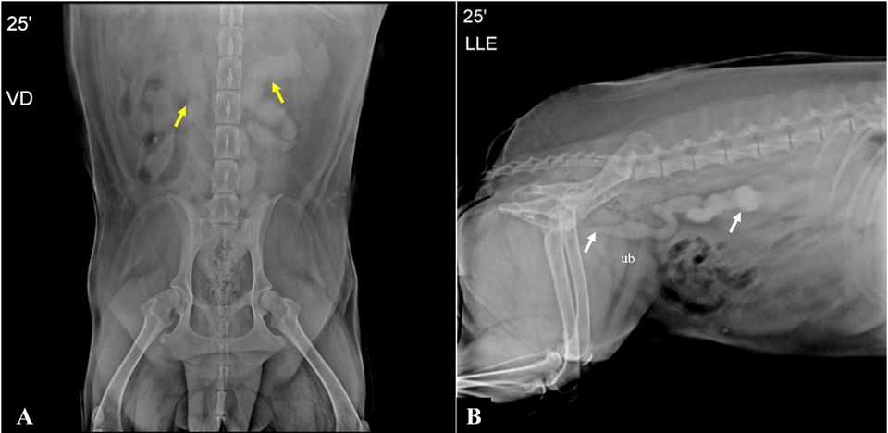
Figure 1. Ventrodorsal projection radiograph of excretory urography. A. at 25 minutes, showing bilateral dilation of ureters (arrows). B. Left lateral projection radiograph of excretory urography at 25 minutes, showing possible left ureteral insertion of the urinary bladder (vu) in the proximal urethra (arrow).

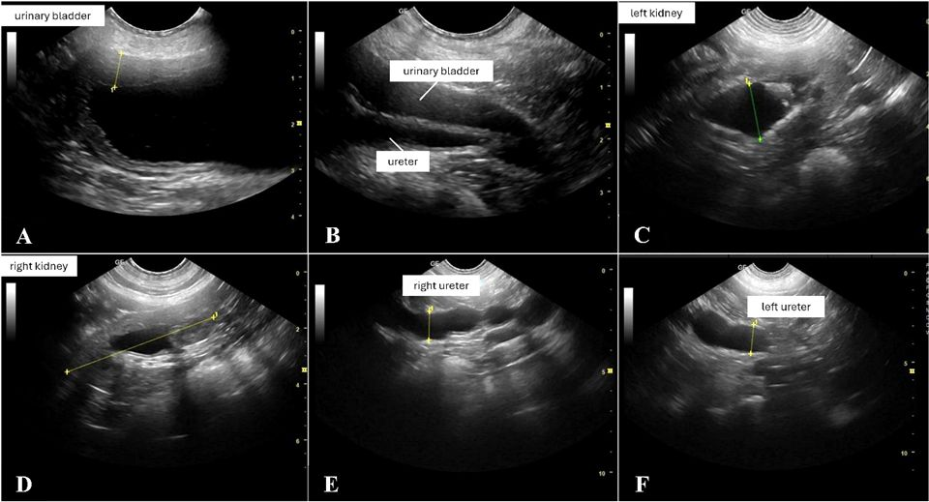
Figure 2. Abdominal ultrasound in a Golden Retriever dog. A. Ultrasound demonstrating spacing of the urinary bladder mucosa, suggesting cystitis. B. Ultrasound image suggestive of extramural left ureter. C, D. Left and right kidneys with dilation of the renal pelvis (pyelectasis). E, F. Right (1.41 cm) and left (1.60 cm) ureter with dilation, suggestive of hydroureter.

The linea alba was exposed, and the musculature was incised in a thrust with a No. 11 scalpel blade. The urinary bladder was identified, isolated, and exposed, and the ureters were inspected. The right ureter had a prevesical bifurcation (Figure 3A), with one branch directed to the urinary bladder and the other to the retroabdominal region.

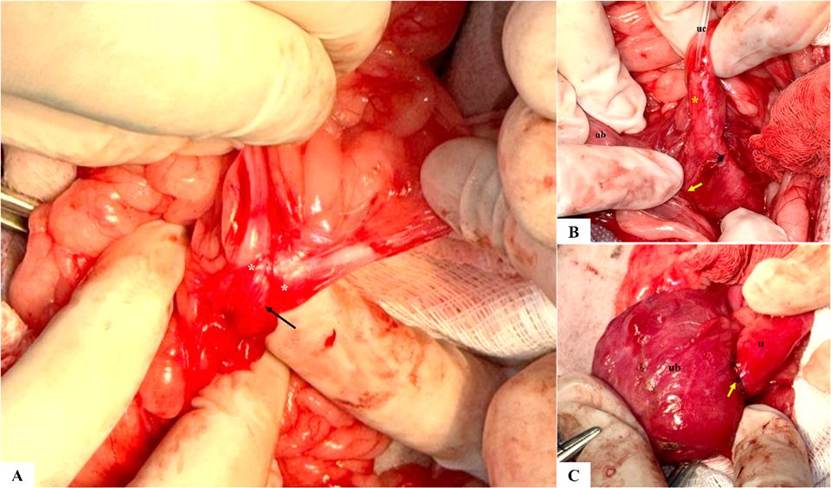
Figure 3. Transoperative image of a Golden Retriever dog. A. Adhesion (*) and bifurcation of the right ureter (arrow) can be observed. B. Left ureter (*) with urethral catheter (uc), urinary bladder (ub), left ureter towards the proximal urethra (arrow). C. Ureter (u) fixed in the new bladder orifice (ub) with a separate simple suture pattern (arrow).

The urinary bladder was sutured with absorbable monofilament suture poliglecaprone 25® 2-0 in a simple continuous pattern, followed by continuous Cushing suture. Myorrhaphy was performed with poliglecaprone 25® No. 0 in a simple continuous pattern on the muscle fascia. The subcutaneous space was reduced by means of zigzag suture using poliglecaprone 25® No. 0. Dermorrhaphy was performed in an intradermal pattern with poliglecaprone 25® cuticular 3-0.
After completion of the procedure, a new catheterization with a Foley catheter No.10 was performed during the hospitalization period. The urethral catheter was kept in place for 12 hours and then removed in order to evaluate the dog's spontaneous urination. The patient remained hospitalized for 24 hours and was discharged after presenting stable clinical parameters and satisfactory evaluation by the responsible surgical team. During the 24 hours of hospitalization, the patient received methadone 0.2 mg/kg TID, ketamine 0.5 mg/kg BID, dipyrone 25 mg/kg BID, dexamethasone 0.15 mg/kg SID, ondansetron 0.5 mg/kg TID and cefazolin 25 mg/kg BID. Proteus mirabilis infection was treated with cephalexin 30 mg/kg BID for 7 days postoperatively.
In the immediate postoperative period, an abdominal ultrasound was performed focusing on the urinary tract, which showed reactive mesentery due to the surgical procedure and bilateral pyelectasis. Eight days after the intervention, the patient had residual urinary incontinence. Therefore, a new ultrasound was performed, demonstrating satisfactory evolution in the left ureter and preservation of the right ureter, in addition to improvement in pyelectasis. When the animal was returned for treatment to remove the surgical stitches, it did not present urinary incontinence, as reported by the owners and observed in the outpatient clinic, and was therefore discharged from surgery.

RESULTS AND DISCUSSION

According to (6), the Golden Retriever breed is among the most common breeds that presented UE, in addition to having occurred more frequently in females compared to males, such data converge with the findings of the current study. Studies recommend genetic investigation of UE in Brazil, in order to establish profiles of probable carriers and contribute to early diagnosis (8).
As evidenced in the literature and corroborated by the present study, urinary incontinence and bacterial infection are relevant clinical signs for diagnostic investigation (1, 9). In addition, alterations such as pyelectasis and hydroureter are also frequently reported in the literature (8, 10). However, such findings are not sufficient for diagnostic confirmation, requiring additional tests, such as radiography and ultrasound (11, 12).
As observed by (8), ultrasonography has been shown to be the most effective noninvasive method for diagnosing UE. However, the present study emphasizes the importance of excretory urography in surgical planning, especially in complex cases.
The surgical technique used was ureteroneocystostomy with submucosal tunneling and reimplantation of the left ureter, according to the principles described by (3). A 3:1 ratio between tunnel length and ostium diameter was prioritized to reduce the risk of fibrosis. In the postoperative period, persistent pyelectasis, evidenced by ultrasound, suggests the possibility of anastomotic stenosis or resistance to urinary flow, a complication described in 20-30% of cases (11). (6) highlight that, although surgical correction of ectopic ureter has a favorable prognosis, the rate of postoperative complications is considerable. In the case in question, urinary incontinence persisted, although less frequently, while pyelectasis improved.
Post-surgical urinary incontinence is often associated with concomitant urethral sphincter anomalies (3), reinforcing the need for adjuvant therapies, such as pharmacological treatment with phenylpropanolamine or, in refractory cases, surgical revision. Studies show that up to 40% of dogs with UE may require ongoing medical management (4), highlighting the importance of long-term follow-up.
Furthermore, the post-surgical evolution of UE may vary depending on the presence of concomitant urinary anomalies, such as bladder hypoplasia and sphincter dysfunction, which may compromise the success of isolated surgical correction (1). The combination of early diagnosis and a multimodal therapeutic approach, including surgical and pharmacological interventions, may increase the chances of functional recovery of urination (13). Therefore, strict clinical follow-up is recommended, with periodic assessments through imaging exams and urodynamic tests to monitor vesicoureteral function and therapeutic adjustments as necessary.
Thus, ectopic ureters constitute a congenital anomaly of hereditary origin, whose multimodal diagnosis is essential to determine the best therapeutic approach, often involving surgical intervention. In the reported case, the suspicion of extramural ureteral ectopia was based on the clinical picture of urinary incontinence, and was confirmed by imaging tests, with emphasis on the association between ultrasonography and excretory urography, which are fundamental for adequate surgical planning.

CONCLUSION

This case illustrates the complexity of managing extramural ectopic ureter in dogs, especially when associated with anatomical variations and infectious comorbidities. Despite advances in imaging and surgical techniques, challenges persist. The diagnosis and treatment of extramural ectopic ureter require an integrated approach, combining advanced imaging tests and meticulous surgical procedures. In addition, it highlights the importance of ultrasonography associated with excretory urography for accurate diagnosis and more efficient surgical planning. Therefore, early identification, use of appropriate diagnostic techniques and individualized management are essential to improve the quality of life of patients affected by this condition.

CONFLICT OF INTEREST

The authors declare that there is no conflict of interest.

REFERENCES

1. Mcloughlin MA, Chew DJ. Diagnosis and surgical management of ectopic ureters. Clin Tech Small Anim Pract. 2000;15(1):17-24. doi: 10.1053/svms.2000.7302.

2. Zachary JF. Bases da Patologia em Veterinária. 6a ed. Rio de Janeiro: GEN; 2017.
3. Fossum TW. Small Animal Surgery. 5th ed. Philadelphia: Elsevier; 2019.

4. Nelson RW, Couto CG. Medicina interna de pequenos animais. 5a ed. Rio de Janeiro: GEN; 2015.

5. Ho LK, Troy GC, Waldron DR. Clinical outcomes of surgically managed ectopic ureters in 33 dogs. J Am Anim Hosp Assoc. 2011;47(3):196-202. doi: 10.5326/JAAHA-MS-5495.

6. Reichler IM, Specker CE, Hubler M, Boos A, Haessig M, Arnold S. Ectopic ureters in dogs: clinical features, surgical techniques and outcome. Vet Surg. 2012;41(4):515-22. doi: 10.1111/j.1532-950x.2012.00952.x.

7. Espada Y, Novellas R, Ruiz de Gopegui R. Renal Ultrasound in Dogs and Cats. Vet Res Commun. 2006;30(1):133-7. doi: 10.1007/s11259-006-0026-8.

8. Costa Neto JM, Silva AE, Martins Filho EF, Ribeiro LGR, Gama ROG, Penha EM, et al. Ectopia ureteral em cães: relato de dois casos. Arq Cienc Vet Zool [Internet]. 2011 [cited 2025 Mar 28];14:151-6. Available from: http://www.repositorio.ufba.br/ri/handle/ri/10991

9. Pollaci E, Balligand M, Hamaide A. Les uretères ectopiques chez le chien Revue de la littérature et présentation de 3 cas chez le chien mâle. Ann Med Vet [Internet]. 2004 [cited 2025 Mar 27];148:103-9. Available from: http://www.facmv.ulg.ac.be/amv/articles/2004_148_2_05.pdf

10. Bianchi SP, Gouvea AL, Macedo AS, Valente FS, Ledur GR, Alievi MM, et al. Ureter ectópico extramural em cadela. Acta Sci Vet [Internet]. 2013 [cited 2025 Mar 27];41(Suppl 1):1-4. Available from: https://www.ufrgs.br/actavet/41-suple-1/CR_1.pdf

11. Elliot J, Grauer GF, Westropp JL, editors. BSAVA Manual of Canine and Feline Nephrology and Urology. 3rd ed. Gloucester: BSAVA; 2017.

12. Dyce KM, Sack WO, Wensing CJG. Textbook of Veterinary Anatomy. 5th ed. St Louis: Saunders; 2018.

13. Berent AC, Weisse C, Mayhew PD, Todd K, Wright M, Bagley D. Evaluation of cystoscopic-guided laser ablation of intramural ectopic ureters in female dogs. J Am Vet Med Assoc. 2012;240(6):716-25. doi: 10.2460/javma.240.6.716.

Recebido em: 2/03/2026
Aceito em: 15/04/2026

Graduada em Medicina Veterinária pela Universidade Federal Rural da Amazônia, doralicelo60@gmail.com
Médico Veterinário, Hospital Veterinário Cora 24h, iuryazev@gmail.com
Universidade Federal Rural da Amazônia, medvet.elaine@gmail.com
Docente de Clínica Cirúrgica Veterinária da Universidade Federal Rural da Amazônia, rosa.cabral@ufra.edu.br

